select \*

from Student

where Sdept in('CS','IS')

order by Sno,Sdept ASC;

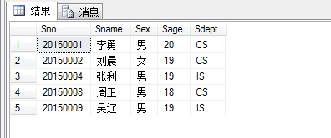

select Sage

from Student

where(Sage = ( select MIN(Sage) from Student) );

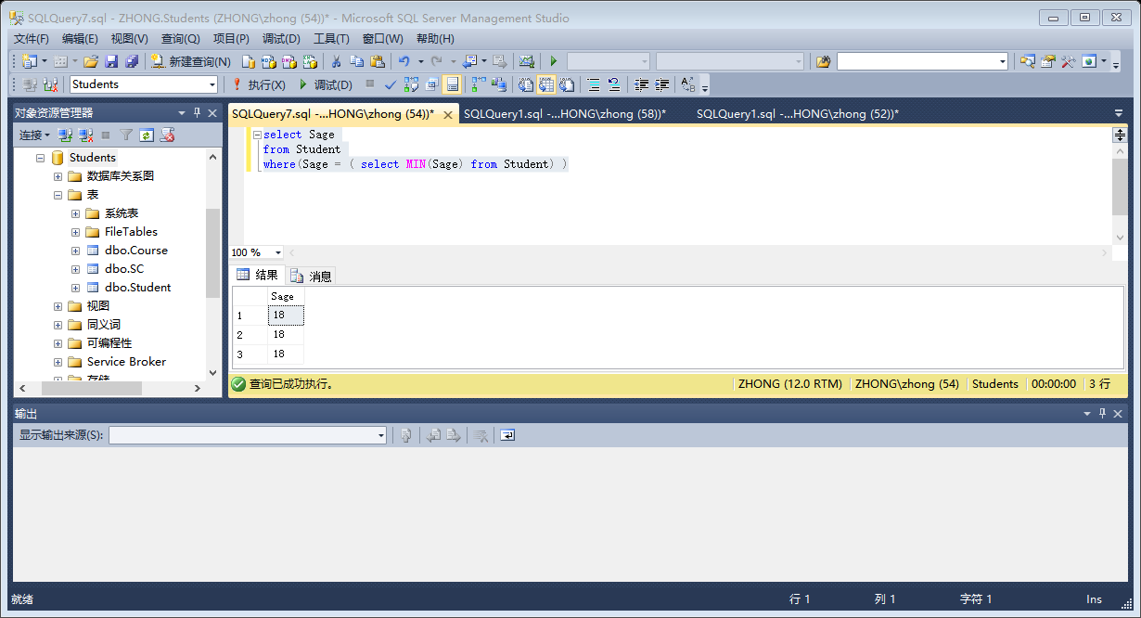

select Cname

from Course

where Cname in('设计')；

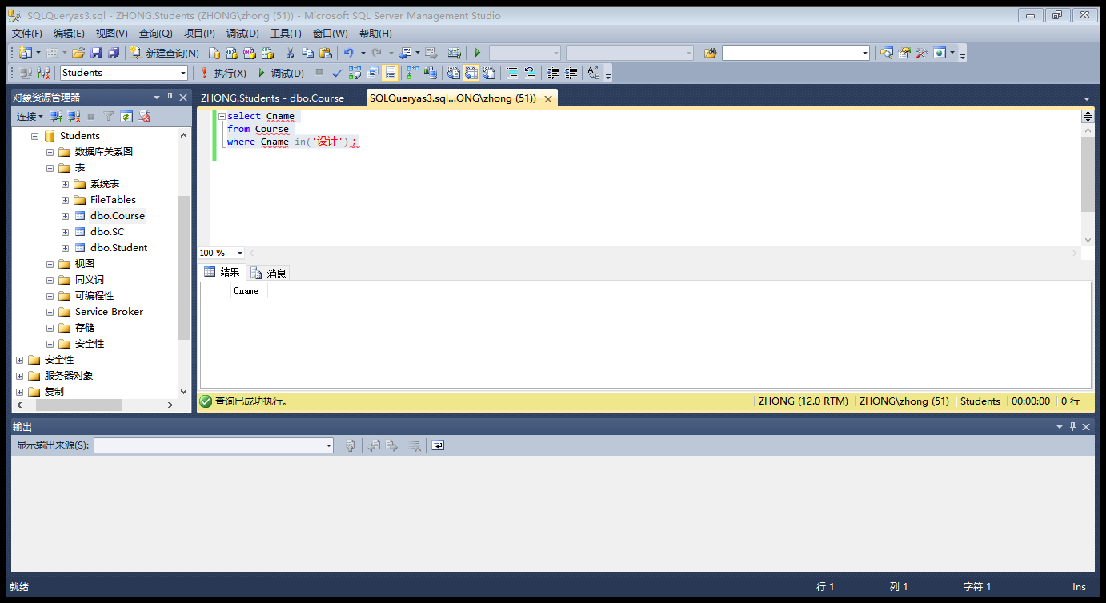

select Cno,Cname,Ccredit

from Course

where Cpno is NULL;

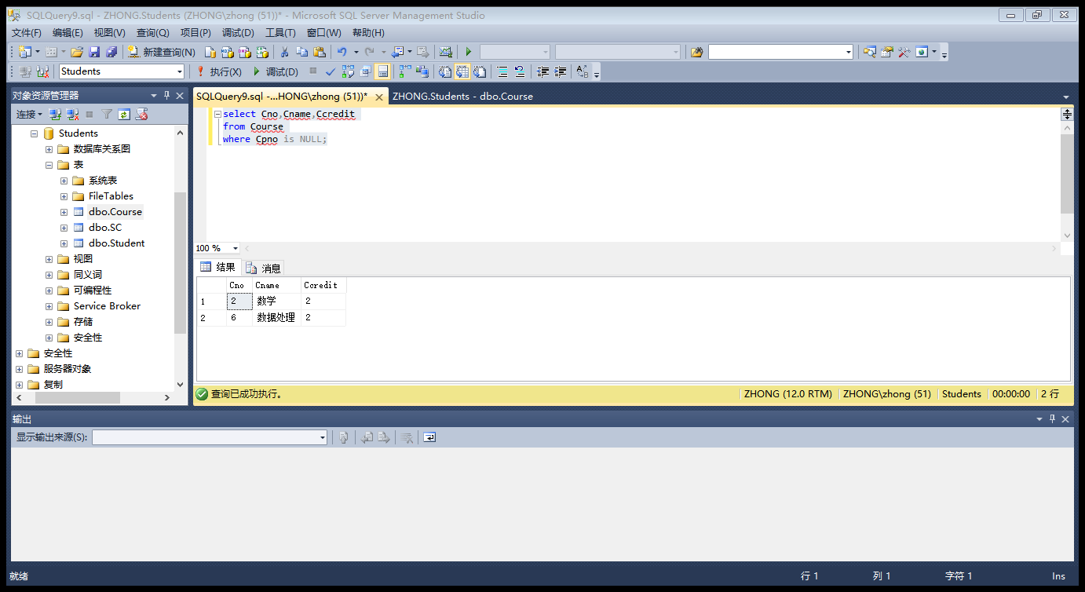

select Grade

from Student,Course,SC

where Student.Sno = SC.Sno

and Course .Cno = SC.Cno

and Student.Sname = '李勇'

and Course.Cname = '数据库'

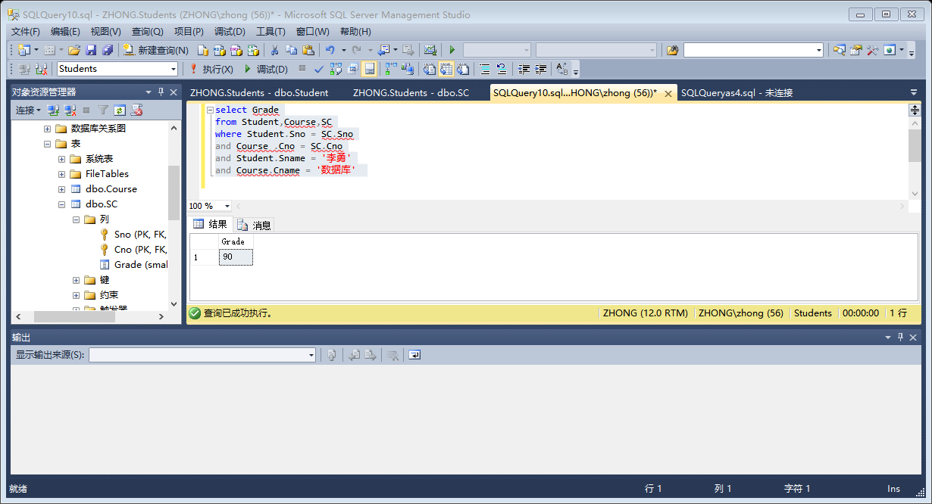

select Sno

from SC

group by Sno

having AVG(Grade)>80

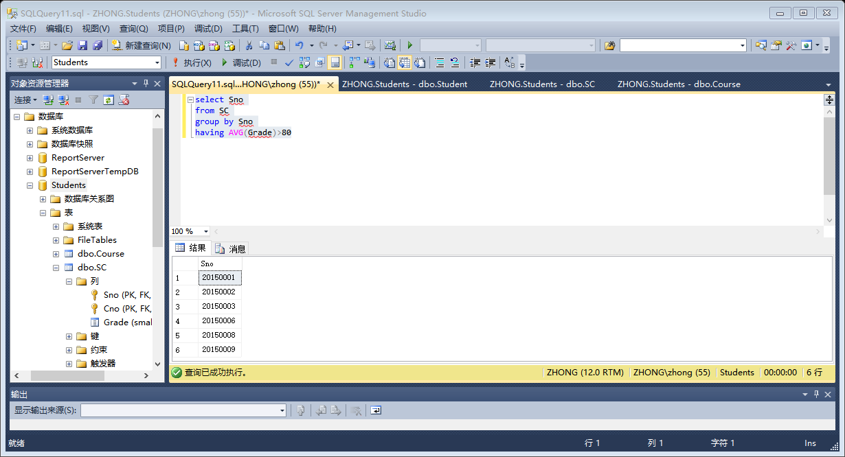

select Sname

from Student

where Sdept = 'CS' and not exists

(select \*

from Course,SC

where Student.Sno = SC.Sno

and Course.Cno = SC.Cno

and Course.Cname = '数据库'

)

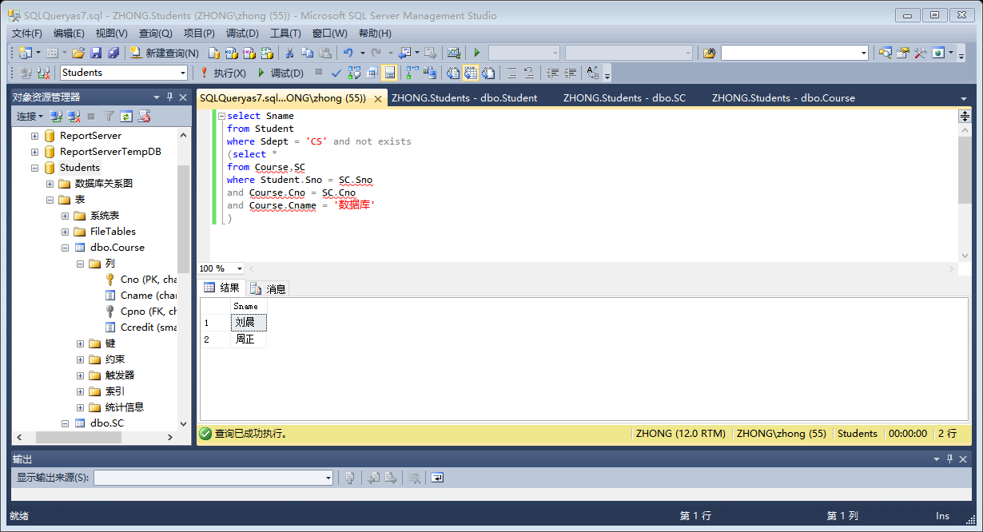

select distinct Sno

from SC SCX

where not exists

(select \*

from SC SCY

where SCY.Sno = '20150003'and

not exists

(select \*

from SC SCZ

where SCZ.Sno = SCX.Sno and

SCZ.Cno = SCY.Cno

)

)

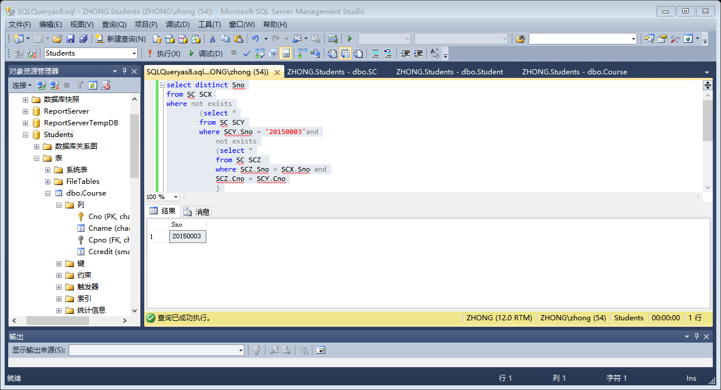

select Sdept,count(Sno)

from Student

group by Sdept

order by count(Sno) DESC

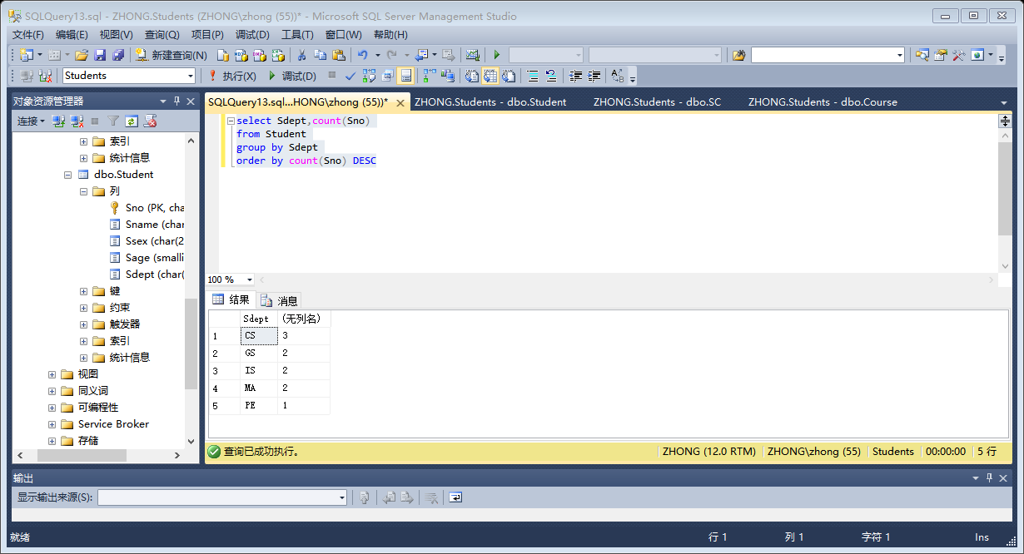

select Sno,Grade

from SC,Course

where Cname = '数据库'

and SC.Cno = Course.Cno

and Grade>(

select AVG(Grade)

from SC,Course

where Cname = '数据库'

and SC.Cno = Course.Cno

group by SC.Cno

)

